SAMBO-WebApp-Session Installation Guide

Setup SAMBO-WebApp-Session Project in NetBeans IDE

- Open NetBeans IDE and load in the project in the <Project Folder>
Open ‘Project Properties’ windows, and choose the Apache Tomcat Server to use. (Current system has been tested under Java1.7, Apache Tomcat 5.5.7, 5.5.9 and 6.0.18.)
- Setup the database
  - Install MySQL if it has not been installed yet. (Current system has been tested under MySQL-5.0.51b-win32)
  - Run the MySQL server by executing “mysqld.exe” under the folder “bin”
  - Create a database named “dbsambo”
  - Execute the SQL script in the file “dbsambo.sql” to initialize the tables and data
- Configure the Apache Tomcat Server
- For Apache Tomcat 5.5.7 and 5.5.9, copy xercesImpl.jar and xml-apis.jar in <Project Folder>\web\WEB-INF\lib to <Tomcat home>\common\endorsed.
- For Apache Tomcat 6.0.18 or more advanced version, create a folder named ‘endorsed’ under <Tomcat home>, then copy xercesImpl.jar and xml-apis.jar to <Tomcat home> \endorsed.
- Configure WordNet
  - Install WordNet 2.1 for Windows.
(Available at http://wordnet.princeton.edu/wordnet/download/)
  - In the project window, open the file “/Web Pages/config/wordnet.xml”, and set "dictionary_path" to the directory of WordNet dictionary files
(e.g. <param name="dictionary_path" value="Y:\WordNet-2.1\dict"/>)
- Configure DIG Reasoner
  - In the project folder, run Racer.exe (We run this under academic license). A window will be opened as follows :
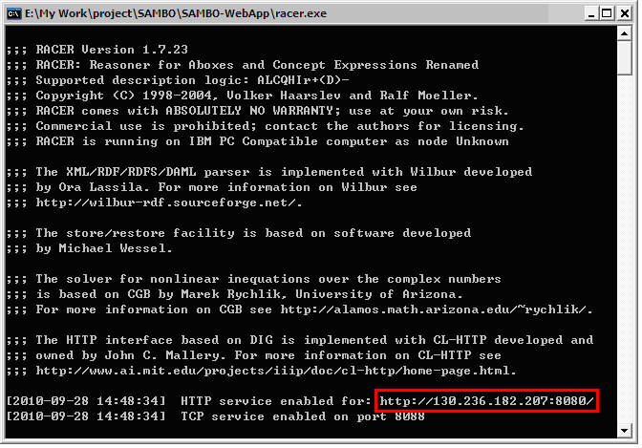
  - In the project window, open “/Web Pages/WEB-INF/web.xml”. On the tab ‘General’, open the section ‘Context Parameters’. Then, edit the param values for parameter ‘Reasoner’ and fill in the http service address of the reasoner (marked in red in above picture).
- Clean and build the whole project.
Run SAMBO-WebApp-Session Service (without IDE)

[NOTE] Currently, the web application works well for small-size ontologies in OWL, as the ones in the folder “<Project Folder>\web\ontologies\OWL”. To align large-size ontologies, please use SAMBO desktop application.

- The project should have been built in IDE. If not, “Clean and Build” the project in the IDE.
- Install Java and JDK, setup the Java environment variables “JAVA_HOME” and “JDK_HOME”
- Install Apache Tomcat Server. Documentation and binaries for Tomcat are available at http://tomcat.apache.org. (The current system has been tested under Apache Tomcat 5.5.7, 5.5.9 and 6.0.18.)
- Setup the database
  - Install MySQL if it has not been installed yet. (Current system has been tested under MySQL-5.0.51b-win32)
  - Run the MySQL server by executing “mysqld.exe” under the folder “bin”
  - Create a database named “dbsambo”
  - Execute the SQL script in the file “dbsambo.sql” to initialize the tables and data
- Configure the Apache Tomcat Server
- For Apache Tomcat 5.5.7 and 5.5.9, copy xercesImpl.jar and xml-apis.jar in <Project Folder>\web\WEB-INF\lib to <Tomcat home>\common\endorsed.
- For Apache Tomcat 6.0.18 or more advanced version, create a folder named ‘endorsed’ under <Tomcat home>, then copy xercesImpl.jar and xml-apis.jar to <Tomcat home> \endorsed.
  - After installation, locate the “Connector” in <Tomcat home>/conf/server.xml with port="8080" setting, and modify the port value. (e.g. 8086).
This is to resolve the problem of port confliction with DIG Reasoner.
- Install SAMBO
  - Make a directory “sambo” under <Tomcat home>\webapps\
  - Copy things under “<Project Folder>/build/web” to the “sambo” directory.
- Install and configure WordNet
  - Install WordNet 2.1 for Windows.
(Available at http://wordnet.princeton.edu/wordnet/download/)
  - Open the file “<Tomcat home>/webapps/sambo/config”, and set "dictionary_path" to the directory of WordNet dictionary files
(e.g. <param name="dictionary_path" value="Y:\WordNet-2.1\dict"/>)
- Start the Tomcat server by running the file “startup” under <Tomcat home>/bin.
- Start the web browser and open e.g. "http://130.236.184.146:8086/sambo/" or "http://localhost:8086/sambo/" in your web browser.
- Configure DIG Reasoner
  - On SAMBO’s main webpage, click “Ontology Checker” on the left collumn. A new webpage will open, which contains a inputbox for the reasoner’s http service address.
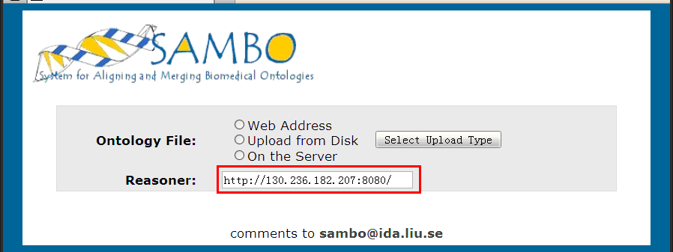

  - Then, run Racer.exe (we run this under academic license), which showing a command window as follows :
  - Copy the http service address in the command windows and paste it into the input box on the webpage, and click “Select Upload Type” button.
- Now, you can go back the SAMBO main page and start your alignment process. Use the user account “tester” with password “tester”, if you are asked to log in.

Email: sambo@ida.liu.se
2011-08-31

